
Growth strategy revised by Wyevale group
By Matthew Appleby Friday, 08 August 2014
Wyevale, the UK's largest garden centre chain, will no longer target buying other big groups as part of its growth strategy, chief executive Kevin Bradshaw has said.

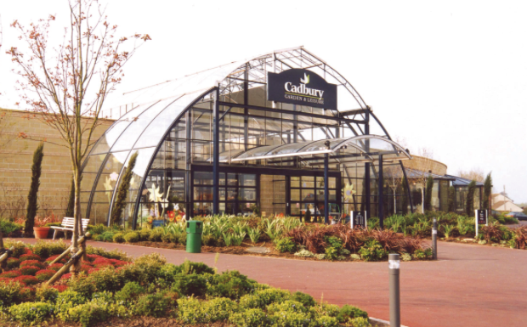

The Terra Firma-owned 140-centre chain, which changed its name from The Garden Centre Group (TGCG) last month, has bought a single centre this year - Brooks in Cornwall.
In October 2012, just after Terra Firma bought TGCG for £276m, chairman Stephen Murphy said the aim was to make up more than 10 per cent of the garden centre market within five-years, which would mean buying chains or enough independents to reach 200 centres.
But Bradshaw has now said: "I'm not sure 200 in the next couple of years is the right benchmark. The reality is it's a quite fragmented industry. As we develop our understanding of the market, my expectation is that you will find the majority of potential acquisitions are from independents and small chains in single or very small numbers."
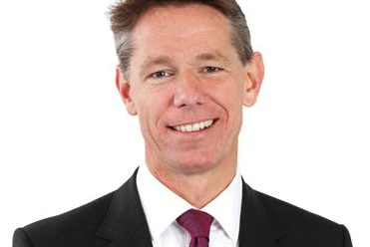
Kevin Bradshaw – Chief Executive

But he added that Wyevale has a "full pipeline of future acquisition prospects" with new buys set to be announced over "the coming months".
The group has a three-way strategy to drive sales - by "improving the strength of the core business", driving sales from existing centres and buying other centres.
It has changed most of its management personnel since 2013 and "reviewing operational processes has seen a strong improvement in gross margin" - from 49 to 52 per cent in 2013.
More concessions, particularly for pets, books (WHSmith) and clothing, brought in almost £1m in additional income in 2013.
Bradshaw said where a third party can do it better, Wyevale will bring it in. "Food we continue to look at," he added. Farm shops, with Walter Smith butchers, are growing as are unmanned food and beverage concessions such as Laithwaites. Concessions numbered 450 in 2012, with income at £14.4m in 2013.
Buying seven Garden & Leisure centres in September 2013, as revealed by HW in July 2013, has been "very positive". Huntingdon is the first to be "overhauled", with a Costa coffee outlet at the front entrance, a farm shop, more concessions and a "more inspiring" planteria.
Bradshaw said the new single Wyevale national brand identity, first revealed by HW in March, brings more public awareness, makes communications more efficient and makes marketing own-label products easier, as well as helping with multichannel retailing "in the future".
On sales, Bradshaw said 2013 was "challenging" with like-for-like turnover flat but up from 2012's £259m to £276m through acquisitions. He said he wants to use earnings before interest, tax, depreciation, amortisation and exceptionals (EBITDA) as the main performance measure because it cuts out one-off fees for cost control and tendering consultants, redundancies and other restructuring, which were high in 2012 and 2013.
He added that 2014 has seen "very good progress" with an "extremely strong first quarter followed by a much more challenging second quarter". Figures will not be available until July 2015.
On pricing, Bradshaw said there is little downward pressure compared to industries such as car rental (he used to work for Avis) because of the fragmented market and little online transparency and comparability.
As for UK sourcing of plants, he said new third-party distribution through Norbert Dentressangle and hubs at Crick and Rochester (HW, 2 August 2013) now give UK-wide access to smaller high-quality growers.
Post Solus, Wyevale sources direct from its old suppliers but will use Scotts for the Solus brands that Scotts bought last month.
Top 10 Garden centres rated by turnover Wyevale's top 10 turnover garden centres are led by three former Garden & Leisure stores:

Rank Name Turnover (July 2013 to June 2014)

1 Cadbury £11,062,722
2 Endsleigh £8,587,203
3 Huntingdon £8,127,170
4 Bridgemere Nursery & Garden World £7,967,118
5 Woodlands Garden Centre & Nurseries £7,605,141
6 Heighley Gate Garden Centre £6,981,868
7 Bicester Avenue Garden Centre £6,898,432
8 World's End Garden Centre £6,651,893
9 Melbicks £6,379,183
10 Sanders Garden World £5,912,069

Read the full article at the link below:-

http://www.hortweek.com/news/1306742/growth-strategy-revised-wyevale-group/

